*Florida International University*

*School of Computing and Information Sciences*

Software Engineering Focus

Feature Document

User Story ID <NVOS-24 View Saved Articles>

**Name:** Bryan Bastida

**Team Member(s):** Bryan Bastida

Andrew Castillo

**Project:** Envo Scholar

**Product Owner(s)**: Mark Finlayson

**Mentor(s)**: Masoud Sadjadi

**Instructor**: Masoud Sadjadi

**User Story Name:**

* As a user, I want to click on a saved articles button, so that I can view my saved articles

Acceptance Criteria

* User has logged into their account
* User has searched for an article
* User has clicked on the Save button
* User goes into their profile
* User profile displays the users saved articles

**Use Case**

* Name: View Saved Articles
* Actor: User, Webpage, MongoDB, User server
* Preconditions: User is logged into their account

User has searched for an article

User has clicked the Save button

* Description <Flow of events>: User logs into their account

User searches for an article

User clicks on the Save button

User clicks on the Account button

Saved articles are displayed to the user

**Use Case Diagram**

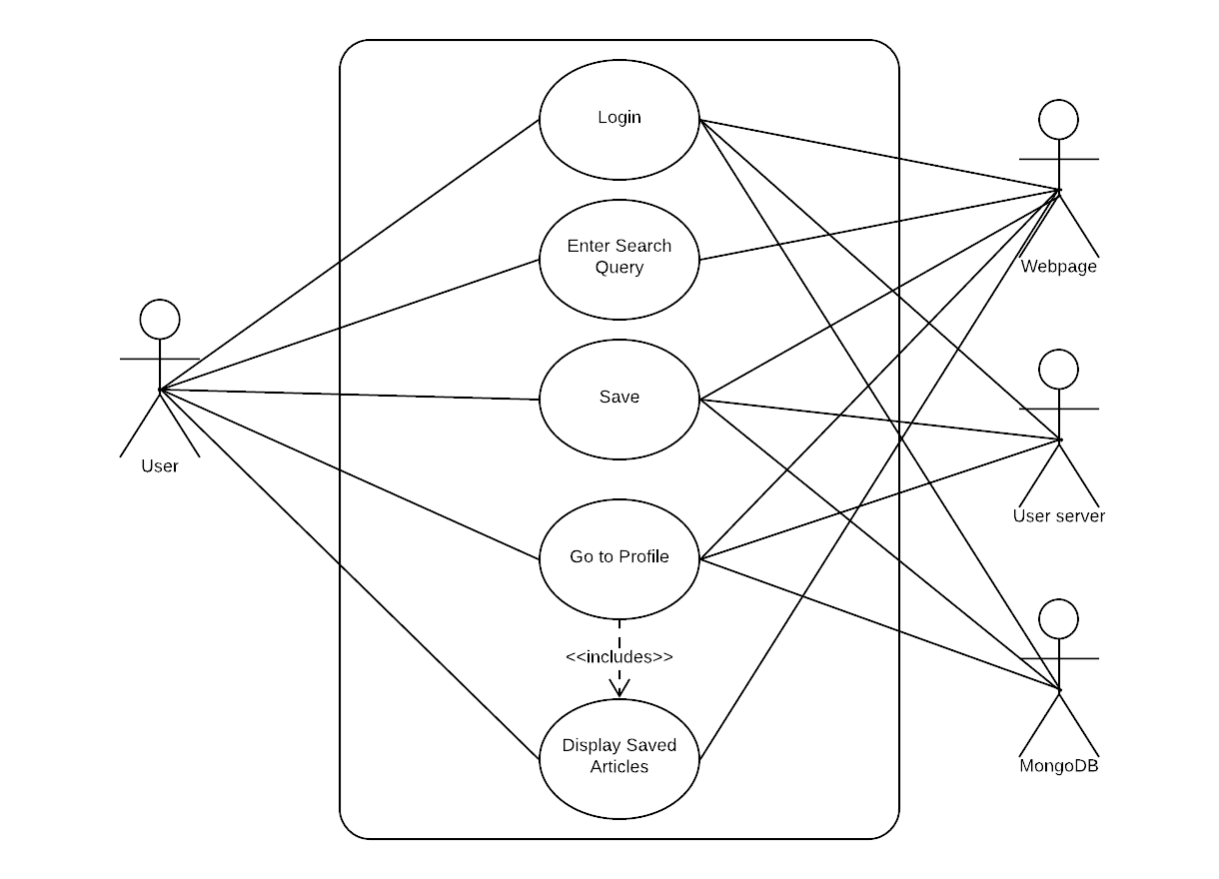

**Sequence Diagram**

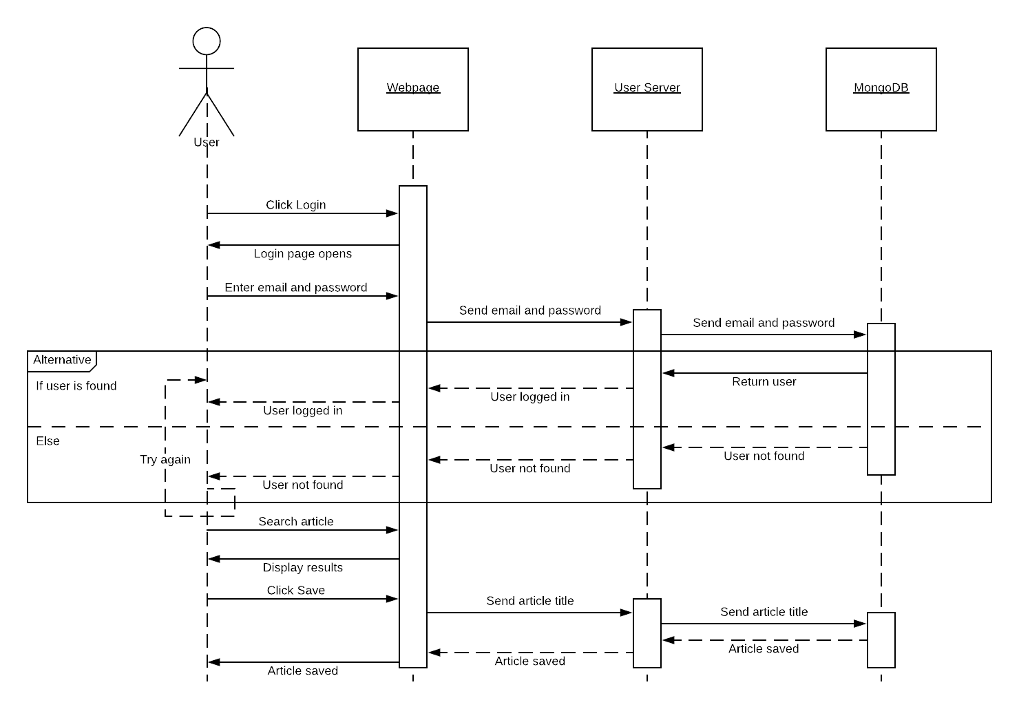**Class Diagram**

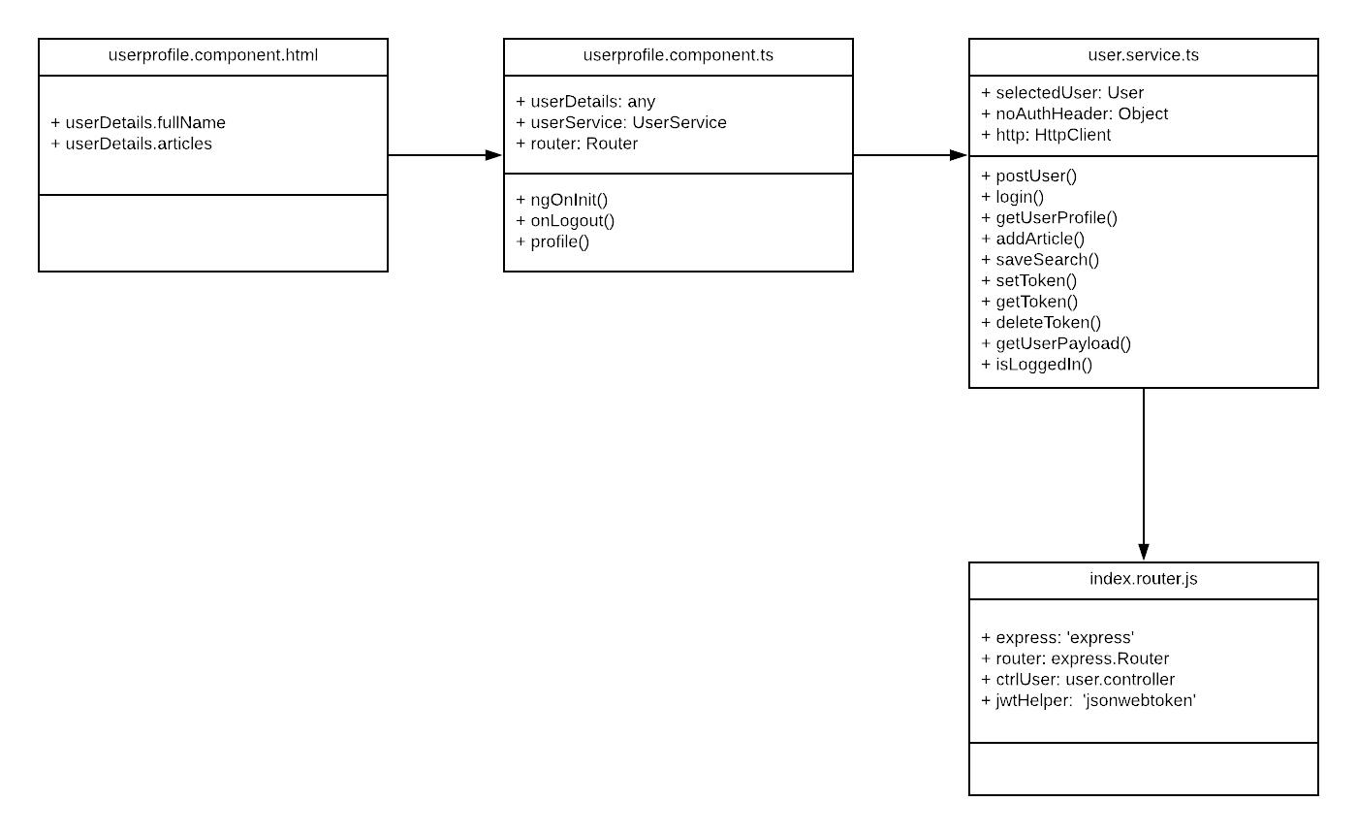

**Unit Test**

* Test case ID: NVOS-24-View-Saved-Articles
* Description/Summary of Test: This test was done to check if a user can view their saved articles
* Pre-condition: User is logged in

User has entered a search

User has clicked on the save button

User accesses their profile page

* Expected Results: Saved articles are displayed in the user profile
* Actual Result: Saved articles are displayed in the user profile
* Status (Fail/Pass): Pass

**Visual User Guide**

